St Paul’s C of E Primary School
Calculation Methods

At St Paul's C of E Primary School, we teach children to develop conceptual understanding through the progression of concrete, pictorial and abstract methods.
Children develop an understanding of a mathematical concept through the three steps of concrete, pictorial and abstract.
Reinforcement is achieved by going back and forth between these representations.
Concrete representation: a pupil is first introduced to an idea or a skill by acting it out with real objects (manipulatives). This is a 'hands on' component using real objects and it is the foundation for conceptual understanding.
Pictorial representation: a pupil has sufficiently understood the hands-on experiences performed and can now relate them to representations, such as a diagram or picture of the problem.
Abstract representation: a pupil is now capable of representing problems by using mathematical notation, for example: 12 ÷ 2 = 6.

ADDITION
Year | Skill & Strategy | Concrete & Pictorial | Abstract
1 | Add two 1-digit numbers to 10  When adding numbers to 10, children will explore both counting how many objects there are altogether (aggregation) and starting at the bigger number and counting on (augmentation).  7 is the whole; 4 is a part and 3 is a part.  The whole is 7 and one part is 3 so the other part must be 4 | 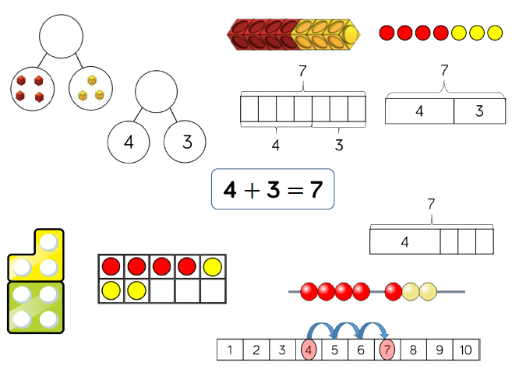 | 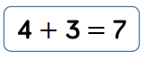
1/2 | Add 1 and 2-digit numbers to 20  When adding one-digit numbers that cross 10, children will use manipulatives to represent ten ones equalling one ten.  I know that 8 plus 7 is equal to 15. | 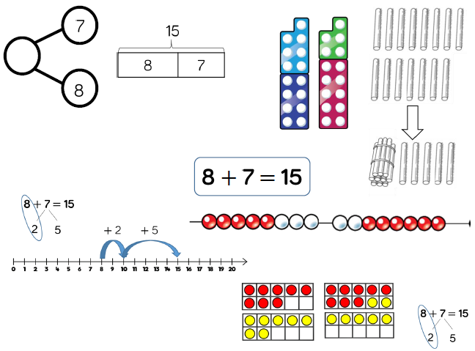 | 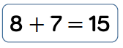
2 | Add three 1-digit numbers  When adding three 1-digit numbers, children will be encouraged to look for number bonds to 10 or doubles to add the numbers more efficiently.  16 is the whole; 7 is a part, 6 is a part and 3 is a part.  There are 7, 6 and 3  Altogether there are 16  I know that when we add three numbers, the total will be the same, whichever pair we add first. | 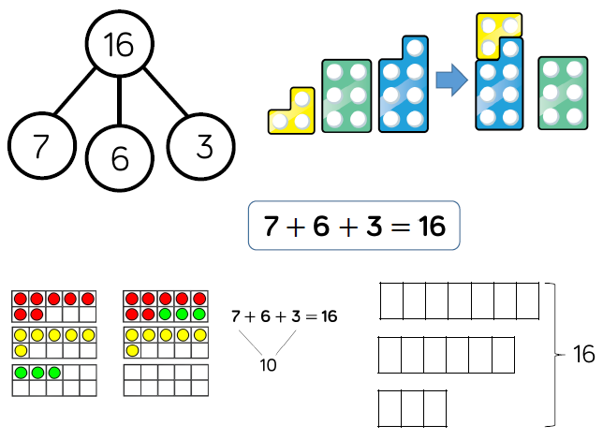 | 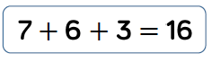
2/3 | Add 1 and 2-digit numbers to 100  When adding single digits to a two-digit number, children will be encouraged to count on from the larger number.  43 is equal to 38 plus 5  38 plus 5 is equal to 43  38 and 5 are the addends  43 is the sum  43 is 5 more than 38 | 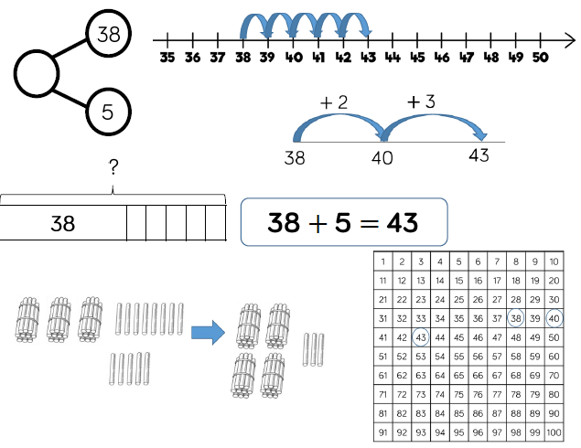 | 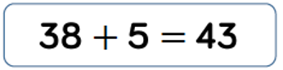
2/3 | Add two 2-digit numbers  At this stage, children will be encouraged to use the formal column addition method, alongside manipulatives.  Children can also use a blank number line to count on to find the total.  61 is the whole; 23 is a part and 38 is a part  For Dienes:  We line up the ones; 8 ones plus 3 ones.  We line up the tens; 3 tens plus 2 tens.  In column addition, we start at the right hand side.  If the column sum is equal to ten or more, we must regroup. | 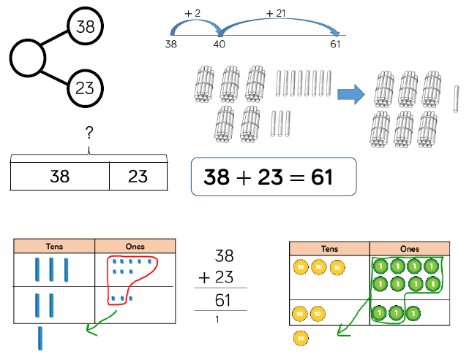 | 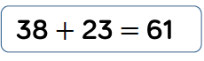  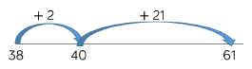  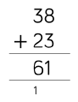
3 | Add with up to 3-digits  Children will continue to use Base 10 and place value counter manipulatives so that they can see the links to the written column method.  For column addition:  The 5 is in the ones column, it represents 5 ones. The 4 is in the ones column, it represents 4 ones. The 6 is in the tens column, it represents 6 tens.  The other 6 is in the tens column, it represents 6 tens. The 2 is in the hundreds column, it represents 2 hundreds. The 1 is in the hundreds column, it represents 1 hundred. | 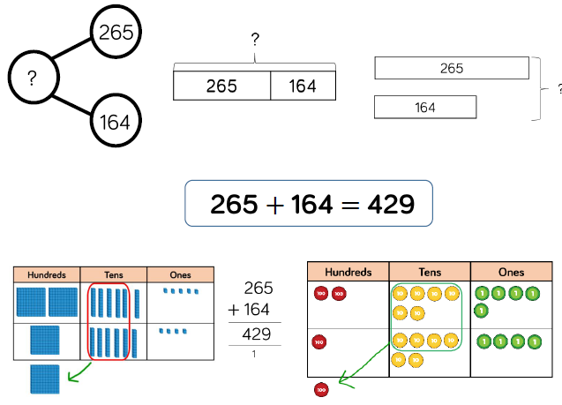 | 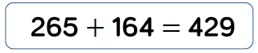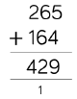
4 | Add with up to 4-digits  Children will continue to use Base 10 and place value counter manipulatives so that they can see the links to the written column method.  If we change the order of the addends, the sum remains the same.  1378+2148=3526  2148+1378=3526 | 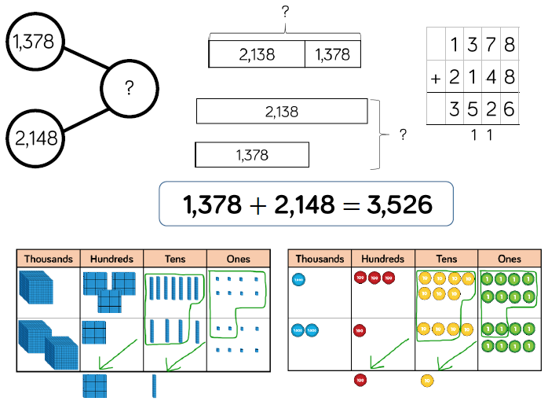 | 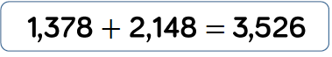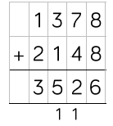
5/6 | Add with more than 4 digits  At this stage, children will be encouraged to work in the abstract, using the column method to add larger numbers efficiently.  First there was 104,328 people.  Then 61,731 people joined the crowd.  Now there are 166,059 people in total. | 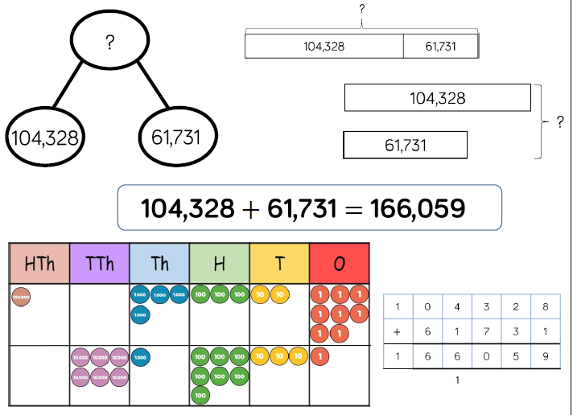 | 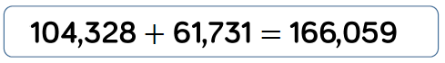  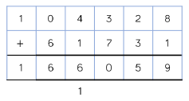
5/6 | Add with up to 3 decimal places  Place value counters will be used on a place value grid when adding decimals using manipulatives.  When using column addition, children will be taught to line up the decimal points so that each digit holds the correct place value.  Decimal language:  I say 2.41 but I think 2 ones, 4 tenths and 1 hundredth. | 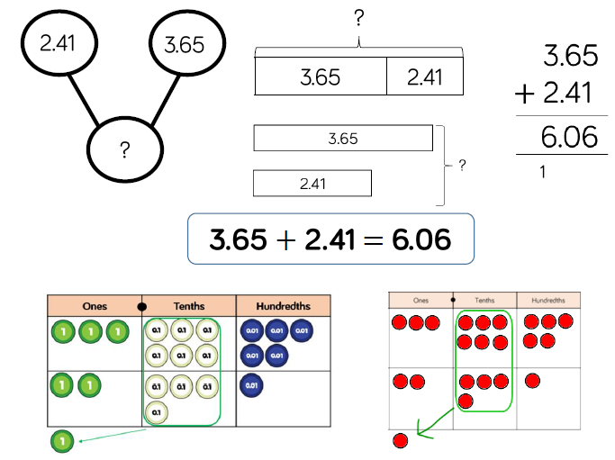 | 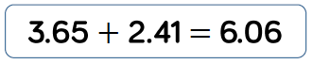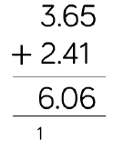

SUBTRACTION
Year | Skill & Strategy | Concrete & Pictorial | Abstract
1 | Subtract two 1-digit numbers to 10  Part-whole models, bar models, ten frames and Numicon support partitioning.  Ten frames, number tracks, single bar models and bead strings support reduction.  Cubes and bar models with two bars can support finding the difference.  The whole is 7. One part is 3 the other part is 4.  I know that a whole is always bigger than a part of the whole. | 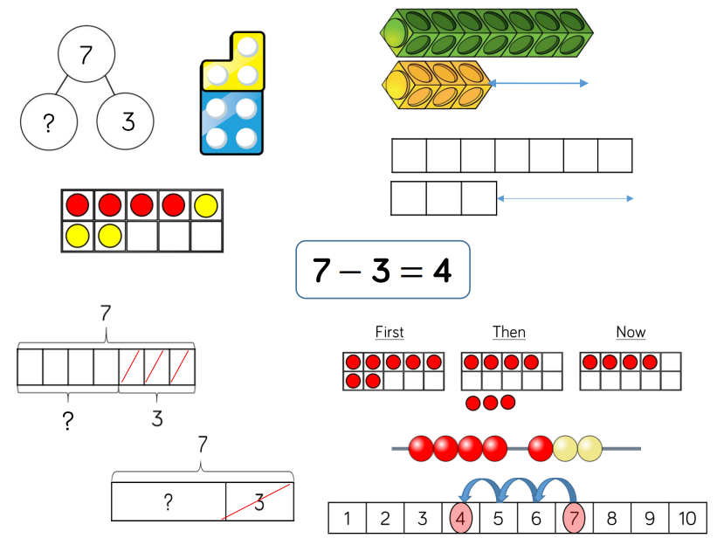 | 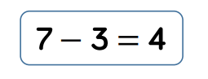
1/2 | Subtract 1 and 2-digit numbers to 20  When subtracting one-digit numbers that cross 10, pupils should be taught the importance of ten ones equalling one ten.  Using manipulatives, children should be encouraged to find the number bond to 10 when partitioning the subtracted number.  The difference between 14 and 6 is 8.  The whole is 14 and one part is 6 so the other part must be _____? | 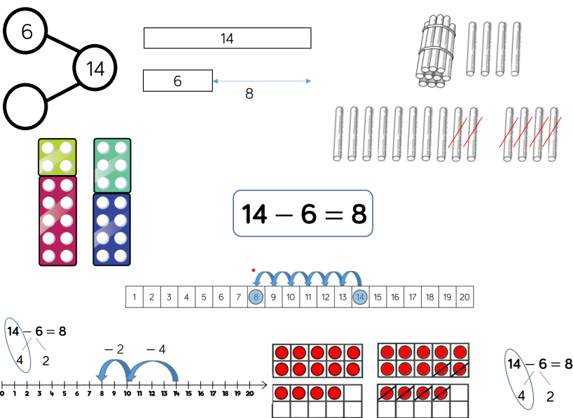 | 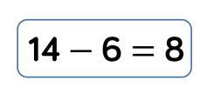
2 | Subtract 1 and 2-digit numbers to 100  At this stage, children will be encouraged to use the formal column method when calculating alongside straws, base ten or place value counters.  Children can also use a blank number line to count on to find the difference.  65 is the whole, 28 is a part and 37 is a part.  65 is 37 more than 28.  37 is 28 less than 65. | 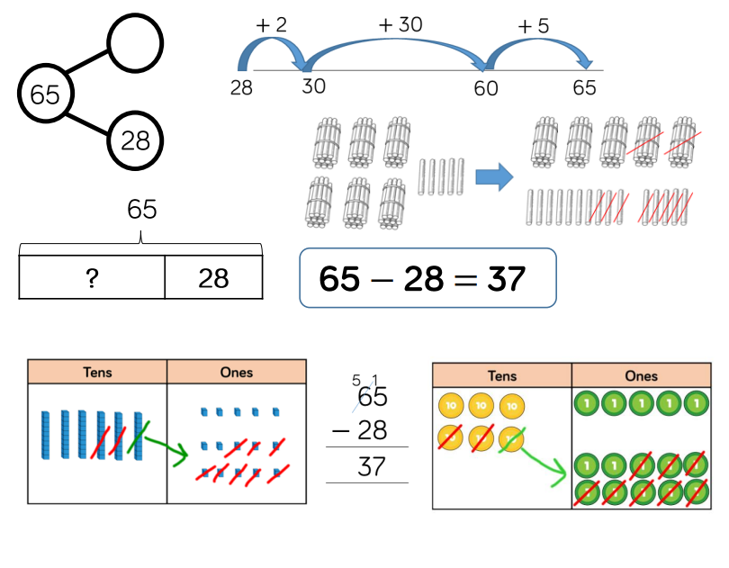 | 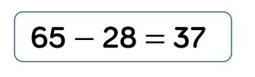
3 | Subtract with up to 3-digits  Children will be encouraged to write out their column subtraction alongside any concrete resources so that they can see the links.  435 is the whole. 273 is a part.  What is the value of the other part?  I know that subtraction is not commutative.  435 – 273 is not equal to 273 – 435. | 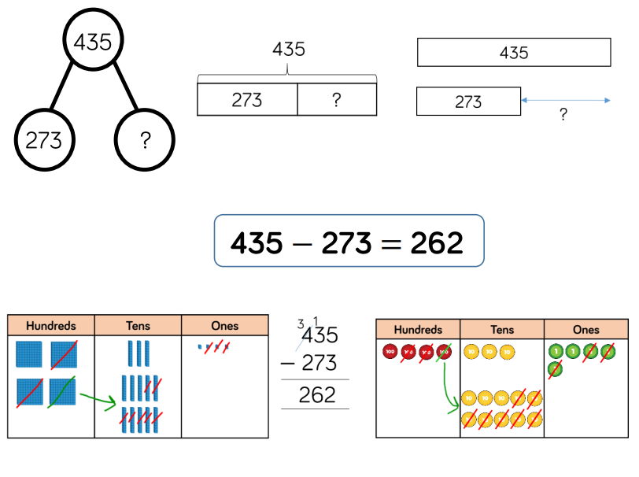  162 | 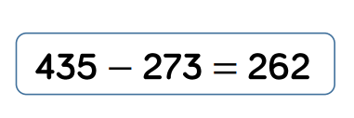  162  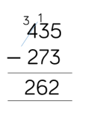  162
4 | Subtract with up to 4-digit  Children will be encouraged to write out their column subtraction alongside any concrete resources so that they can see the links.  I know that I am subtracting one part from the whole to find the other part.  I know that, when using column subtraction, the larger number must be written at the top because of commutative law. | 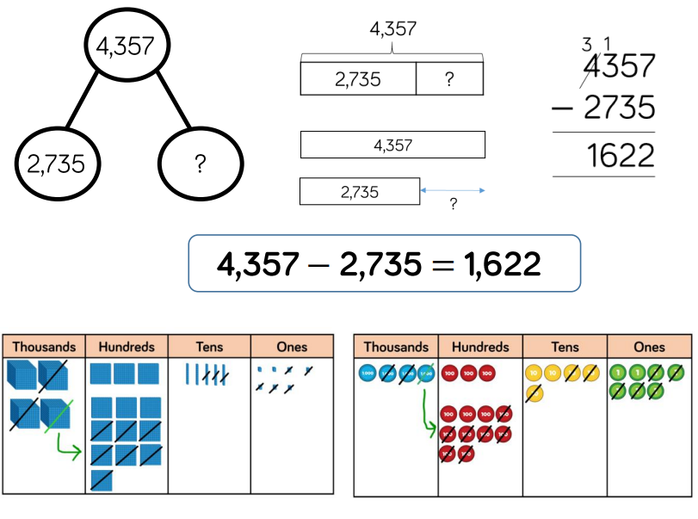 | 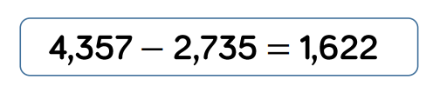  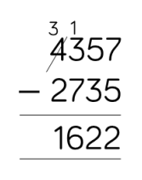
5/6 | Subtract with more than 4 digits  At this stage, children will be encouraged to work in the abstract, using column method to subtract larger numbers efficiently. | 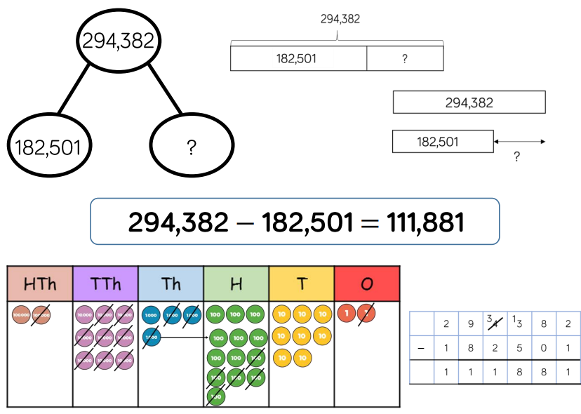 | 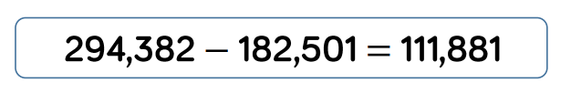  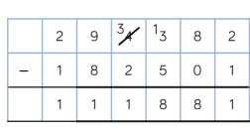
5/6 | Subtract with up to 3 decimal places  Children will have experience of subtracting decimals with a variety of decimal places. This includes putting this into real life contexts when subtracting money and other measures.  I know that the more we subtract, the less we are left with. The less we subtract, the more we are left with.  I know that when using column subtraction to subtract decimals, we must line up the decimal points first. | 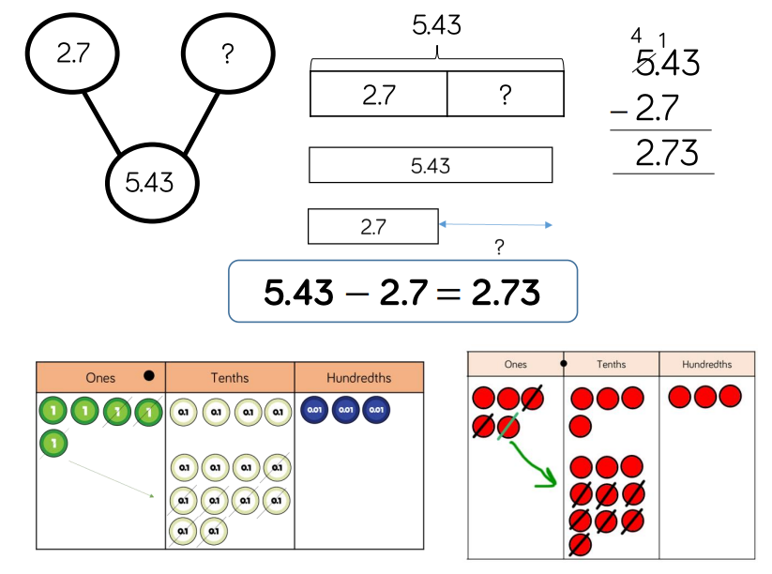 | 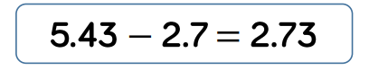  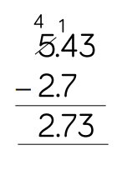

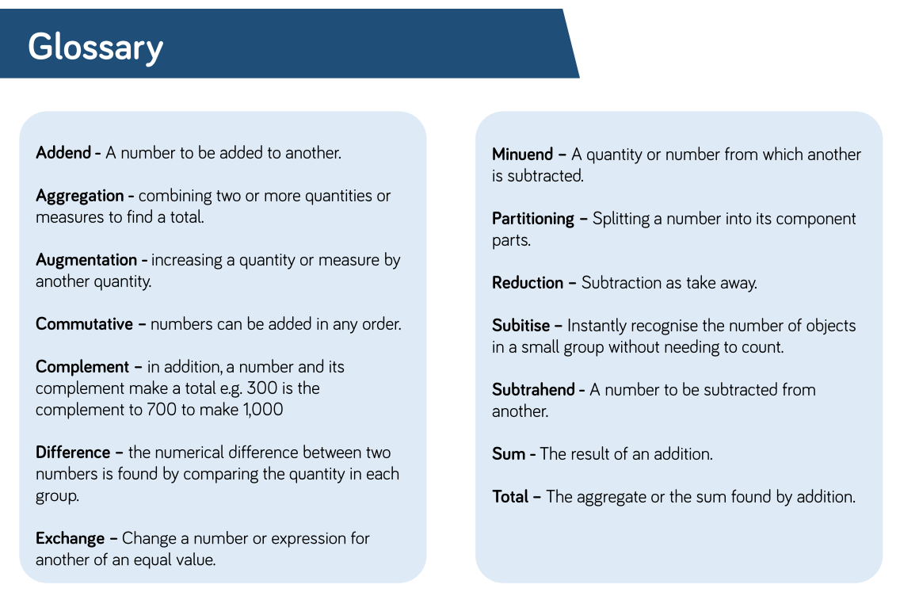

MULTIPLICATION
Year | Skill & Strategy | Concrete & Pictorial | Abstract
1/2 | Solve 1-step problems using multiplication  Children will represent multiplication as repeated addition in many different ways.  In Year 1, children will use concrete and pictorial representations to solve problems. In Year 2, children are introduced to the multiplication symbol.  There are 4 equal groups of apples.  There are 5 in each group.  There are 4 groups of 5. | 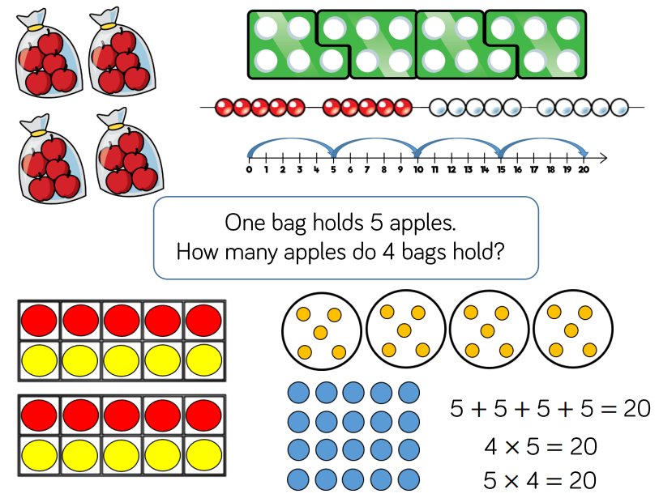 | 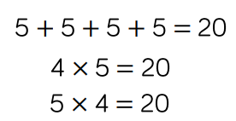
3/4 | Multiply 2-digit numbers by 1-digit numbers  Children will be taught to use the short multiplication method. Place value counters will be used to support understanding of the method. Children will be expected to understand how to exchange and carry to the next column.  By the end of Year 4, children will be expected to know all times table facts up to the12 times table.  Children will need to use times table knowledge to carry out short multiplication.  I know that 34x5 is equal to 5x34.  The product of 34 and 5 is 170. | 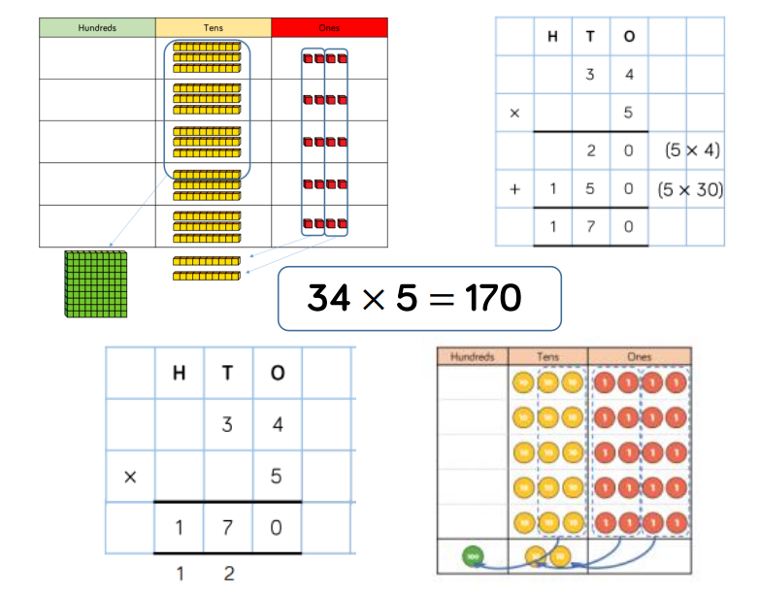 | 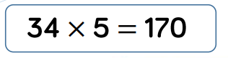  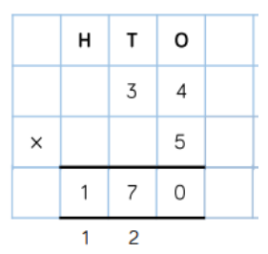
3/4 | Multiply 3-digit numbers by 1-digit numbers  Children will continue to use the short multiplication method. Place value counters will continue to be used to support understanding of the method with 3-digit numbers.  I know that, when multiplying, the order of the numbers does not affect the product.  245x4=980 and 4x245=980  Partition 245 into 200 and 40 and 5.  Multiply the ones, 4x5.  Multiply the tens, 4x40.  Multiply the hundreds, 4x200. | 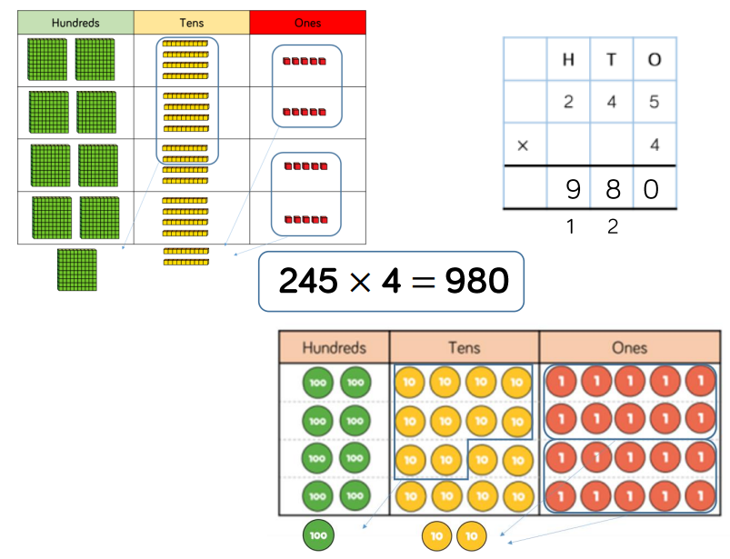 | 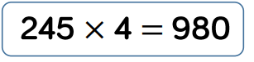  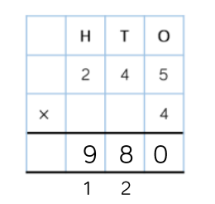
5 | Multiply 4-digit numbers by 1-digit numbers  Children will continue to use the short multiplication method. Place value counters will continue to be used to support understanding of the method with 4-digit numbers. Times table grids may be used when children are not secure with their times tables.  1,826 multiplied by 3 is equal to 1,826 add 1,826 add 1,826. | 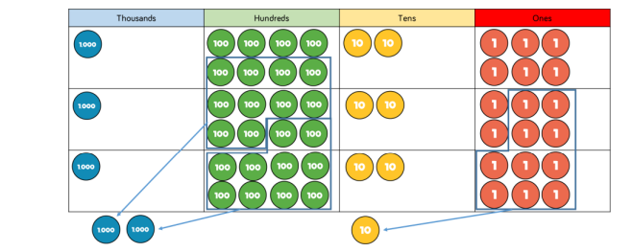 | 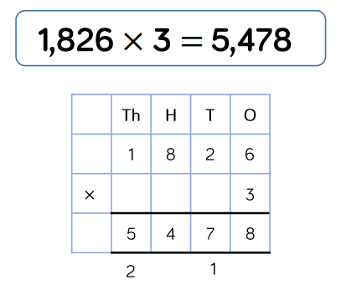
5 | Multiply 2-digit numbers by 2-digit numbers  When multiplying a multi-digit number by 2-digits, children will be shown the area model to support understanding of the size of the numbers they are using.  The grid method matches the area model as an initial written method to support understanding before moving on to the formal long multiplication method. | 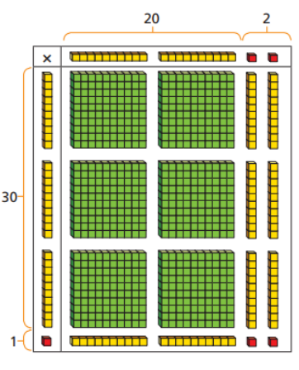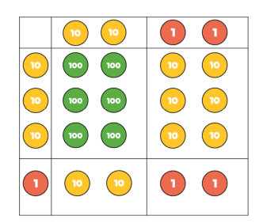  The area model | 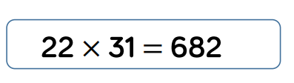  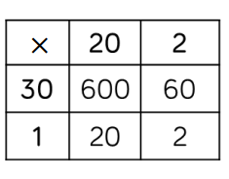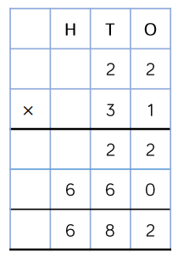
5 | Multiply 3-digit numbers by 2-digit numbers  Children will be encouraged to move towards the formal written method, seeing the link with grid method.  When using long multiplication, first I multiply by the ones. Next, I place a place value holder (0) to show it is ten times the size. Then I multiply by the tens. Finally, I add the partial products together. | 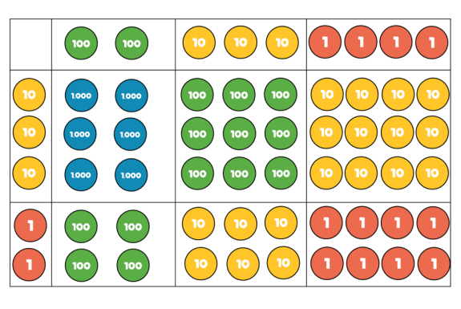 | 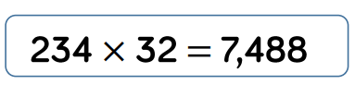  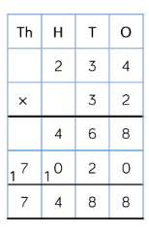  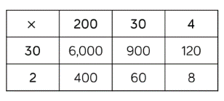
5/6 | Multiply 4-digit numbers by 2-digit numbers  When multiplying 4-digit numbers by 2-digit numbers, children will be confident in the written method. |  | 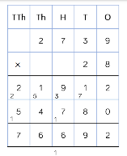  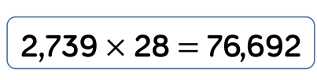

Division
Year | Skill & Strategy | Concrete & Pictorial | Abstract
1/2 | Solve 1-step problems using multiplication (sharing)  Children solve problems by sharing amounts into equal groups.  In Year 1, children use concrete and pictorial representations to solve problems.  In Year 2, children are introduced to the division symbol.  20 shared into 5 equal groups. | 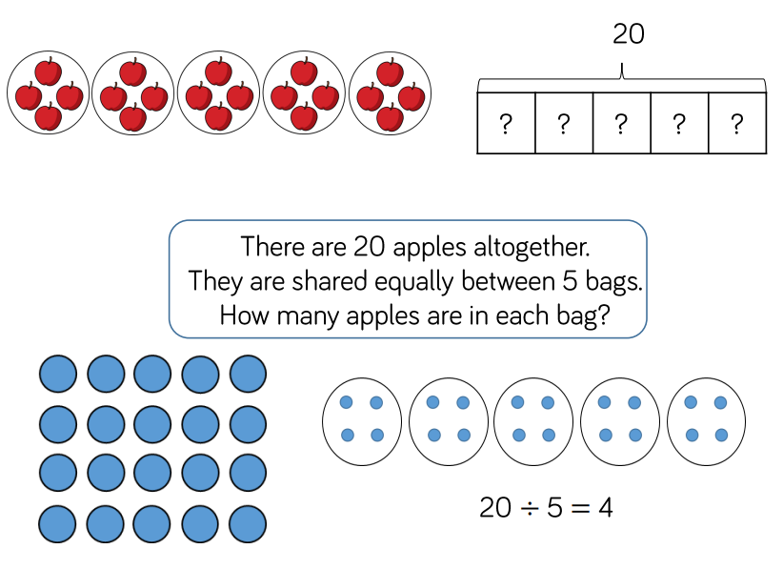 | 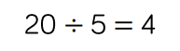
1/2 | Solve one step problems using division (grouping)  Children solve problems by grouping and counting the number of groups. Grouping encourages children to count in multiples and links to repeated subtraction on a number line.  There are 4 groups of 5; there are 20 altogether.  20 is divided into groups of 5. There are 4 groups. | 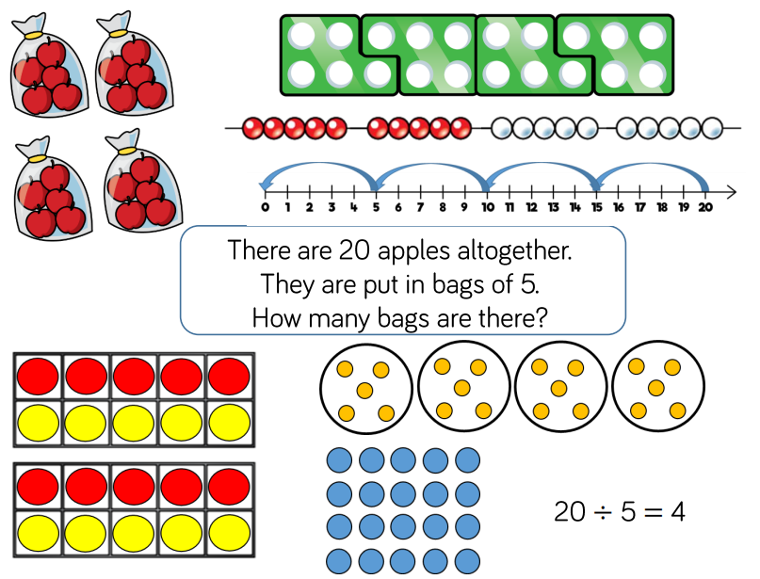 | 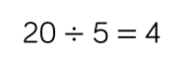
1/2 | Divide 2-digit numbers by 1-digit numbers (sharing with no exchange)  When dividing larger numbers, children can use manipulatives that allow them to partition into tens and ones.  Part-whole models can provide children with a clear written method that matches the concrete representation. | 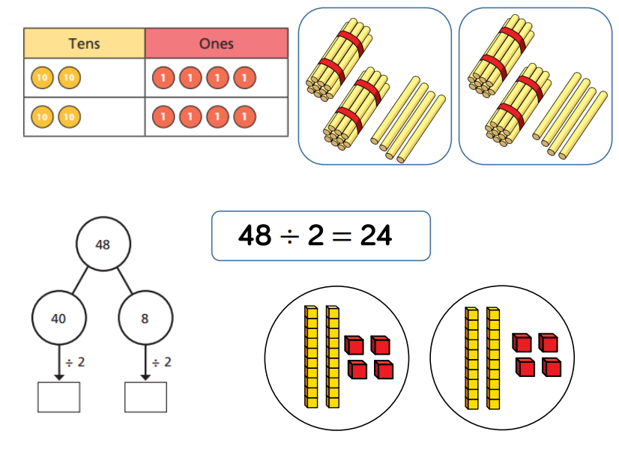 | 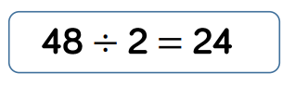
3/4 | Divide 2-digits by 1-digit (sharing with exchange)  When dividing larger numbers children can use Base 10 or place value counters and share them from the table to the place value grid. When dividing numbers involving an exchange, children will be able to see the need to exchange 1 ten for 10 ones.  54 ÷ 4 = 13  Dividend ÷ divisor = quotient  52 is a multiple of 4, so when it is divided into groups of 4 there is no remainder. | 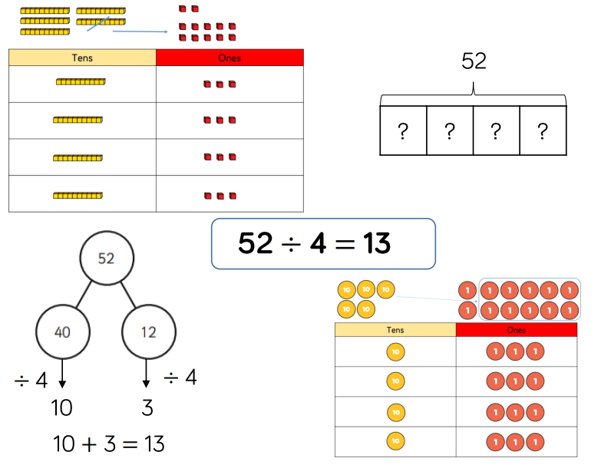 | 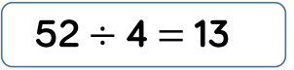
3/4 | Divide 2-digits by 1-digit (sharing with remainders)  When dividing larger numbers children can use Base 10 or place value counters and share them from the table to the place value grid.  Starting with the equipment outside the place value grid will highlight remainders, as they will be left outside the grid once the equal groups have been made.  53 divided between 4 is equal to 13 each with a remainder of 1.  54 ÷ 4 = 13 r1  Dividend ÷ divisor = quotient remainder  I know that the remainder will always be less than the divisor. | 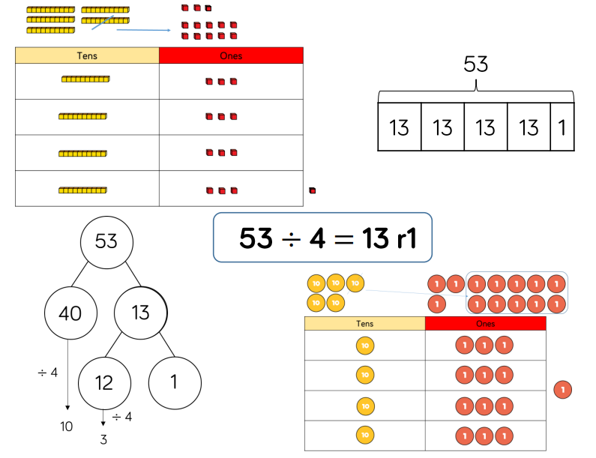 | 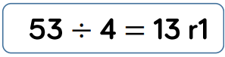
4/5 | Divide 2-digits by 1 digit (grouping)  Children will be taught to use the short division method. Starting with the largest place value, they group by the divisor.  Language is important.  How many groups of 4 can we make from 5? How many groups of 4 can we make from 12?  I know that if the divisor is four, we can use the four times table to find the quotient. | 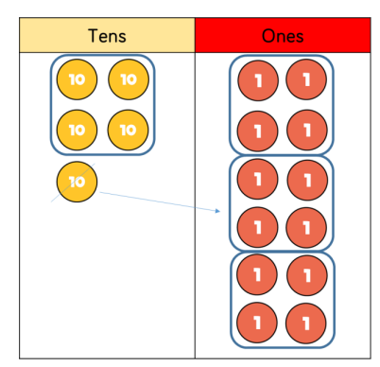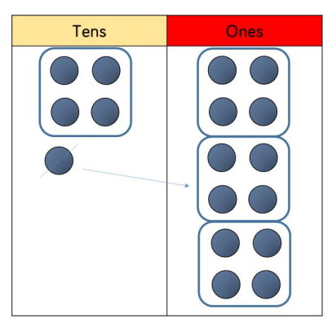 | 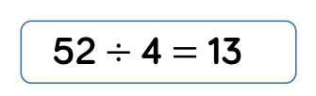  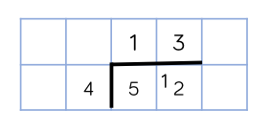
4 | Divide 3-digits by 1-digit (sharing)  When sharing 3-digit numbers into equal groups, children should start with the equipment outside of the place value grid to highlight remainders.  844 ÷ 4 = 211  Dividend ÷ divisor = quotient  844 divided between 4 is equal to 211 each. | 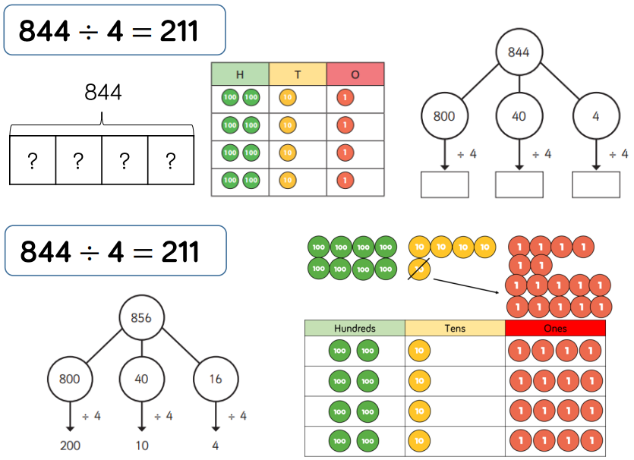 | 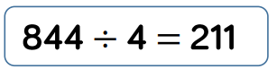
5 | Divide 3-digits by 1-digit (grouping)  Children will continue to use grouping to support their understanding of division. Children can also draw their own counters and group through a more pictorial method.  I know that 856÷4 is not equal to 4÷856 because division is not commutative. | 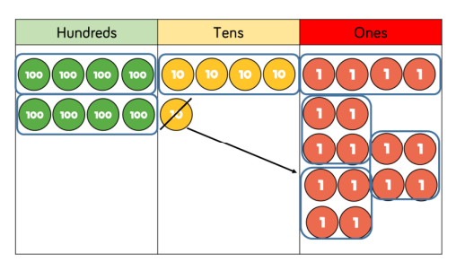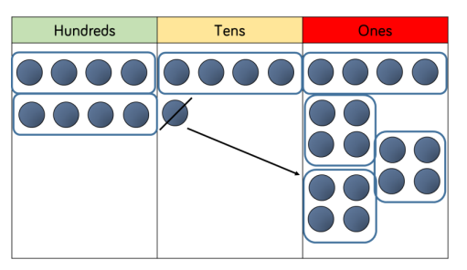 | 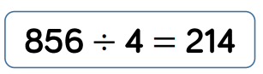  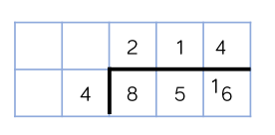
5 | Divide 4-digits by 1-digit (grouping)  Children will continue to use grouping to support their understanding of division. Children can also draw their own counters and group through a more pictorial method.  Children should be encouraged to move away from the concrete and pictorial when dividing numbers with multiple exchanges. | 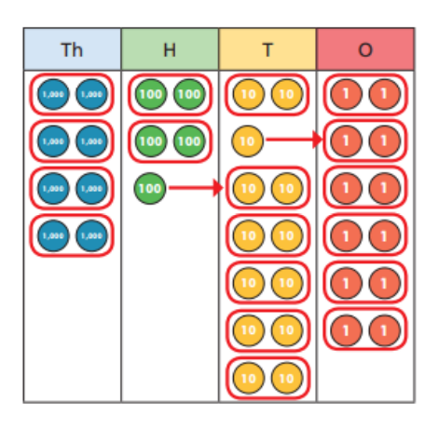 | 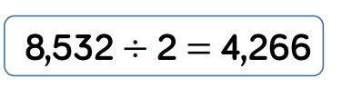  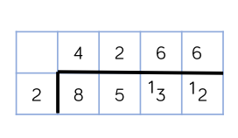
6 | Divide multi digits by 2-digits (long division) with no remainder.  Children will be taught to use the long division method. They will be encouraged to write out multiples to support their calculations.  432 ÷ 12 = 36  Dividend ÷ divisor = quotient  I know that the remainder will always be less than the divisor. |  | 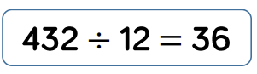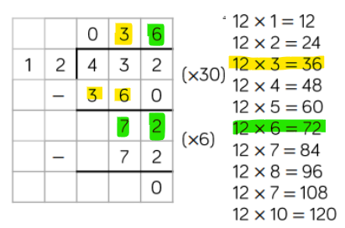
6 | Divide multi digits by 2-digits (long division) with a remainder.  When a remainder is left at the end of a calculation, children can either leave it as a remainder or convert it to a fraction. This will depend on the context of the question.  Children can also answer questions where the quotient needs to be rounded up or down, according to the context. |  | 

