What to wear for Forest School
A base layer, under a t-shirt and jumper in the colder months will keep your children extra warm!
A warm coat, waterproof if possible.
A hat, scarf and if possible waterproof gloves to protect little fingers!

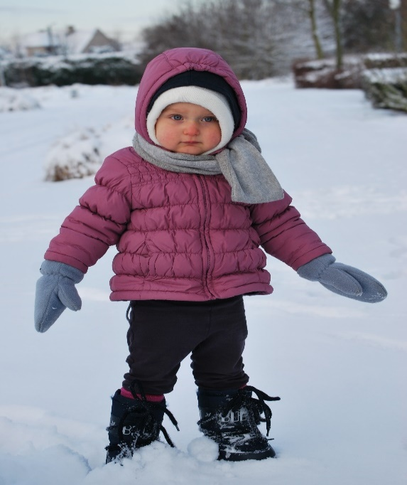
Wellies will keep feet nice and dry.
Old Comfy jogging bottoms are ideal - there will be lots of running, climbing and jumping about!
Even in warmer weather, long trousers and long sleeved T-shirts are best. These help prevent bites, stings and scratches when exploring the areas of long grass at forest school.
Water proofs will be provided if you don’t have your own.
During winter, superhero tights, welly liners or an extra pair of socks can be worn to keep their toes nice and toasty!


Please be aware, we stay outside whatever the weather, we often splash in puddles play in the rain and get muddy! Please make sure your child is suitably dressed. Forest school sessions run for 2 hours during afternoons. It can get very chilly!

Please be aware, we stay outside whatever the weather, we often splash in puddles play in the rain and get muddy! Please make sure your child is suitably dressed. Forest school sessions run for 2 hours during afternoons. It can get very chilly!

