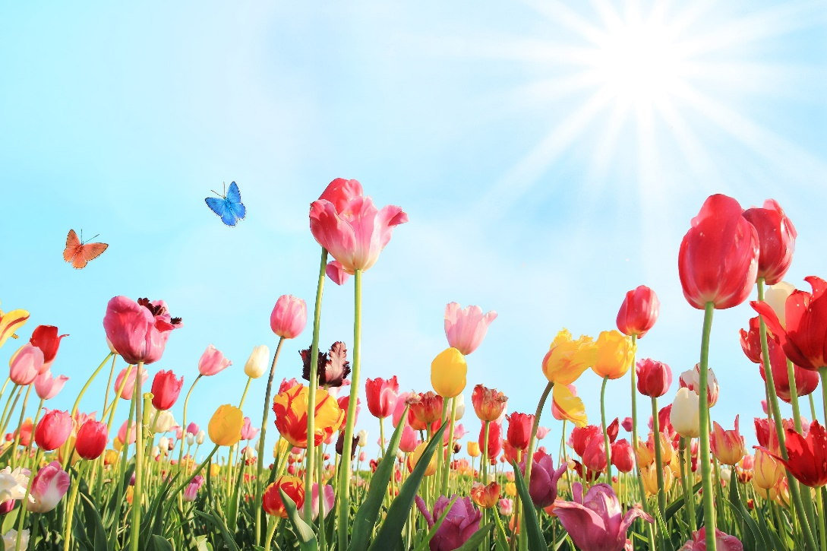
09.03.2026.

- Miss Berte joined us for this meeting and discussed what the school councillors next role would be. She explained as a school we are working towards getting our bee friendly silver and gold awards. To do this they were each given a nature diary. In this, they have to record any bees that they see and what type of bee it is, any particular flowers that they see the bees around, the bee life cycle, any interesting facts they know about bees. The children were given information about the types of bees, their life cycle and what flowers to look out for.
- We discussed that we were going to spend some of the school council money on some dyslexia books for the library.
- I also discussed an idea Mrs Wellicombe brought to me, she said a table would be brilliant for some lessons to be done outside. I found some images of some table ideas and showed these to the children and they really liked it and wanted to make this a goal.
- We discussed fundraising ideas and have decided to do sponsoring. A date will be confirmed for this.

