19.01.2026.
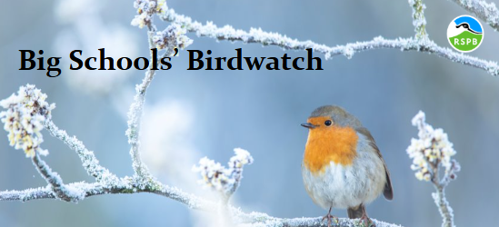

School council meeting.

- Miss Berte joined us today in our School Council meeting to discuss our next project. The children are going to be taking part in RSPB Big School’s birdwatch.
- This helps the RSPB to create a ‘snapshot’ of how birds are doing across UK schools. They have 25 years’ worth of data that can be compared each year. By seeing the number of birds counted during this time, it gives scientists an idea of how other wildlife is doing.
- Overall, if helps us learn which birds are doing well and which are trouble and then work out what needs to be done to help those in need.
- This will take place on the school field in February.
- We discussed other ways we can support the ecosystems at school and one way the School Councillors offered to help was to use some of the money they have raised so far this year to buy some trees/bushes with berries on for the birds to eat.
- We have also decided to try to find a board suitable around school to put up any important school council information for the children to read about and the projects they are doing.
- Suggestion boxes from classes: a whole school litter pick, hand dryers in the toilets, bible areas on playgrounds/ outdoor areas.
- RSPB Bird & Wildlife Conservation Charity

