School Council Meeting.
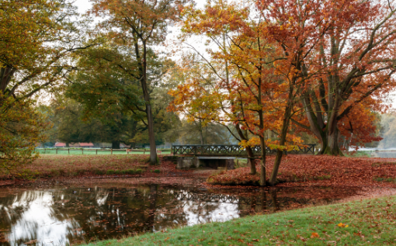
21.09.2026.

A big welcome to all the school council representative! During the first meeting the expectation of what a school council representative is was recapped. It was explained to the children they would be given a task to complete at every meeting and this is to be completed before the next meeting (roughly 3 weeks). The tasks the children were given this week were: to write a message about themselves for the school website. They can have support from parents, teachers etc. it can be emailed to Miss Hammond when complete or given as a paper copy and be handwritten. The second job the children were given was to create a box for their peers in their class to write suggestion ideas to put in the box. These boxes are brought to every school council meeting and shared with the group.

We also discussed different fundraising ideas and the children came up with some really lovely ideas! They also discussed some ways they could improve the school and some things they have noticed around school that they could fix.

